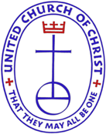

CONGRATULATIONS!
5 FOR 5 Churches in the Pittsburgh Association
2016

First UCC, Millvale
Mt. Troy UCC, Troy Hill
Smithfield UCC, Pittsburgh
St. John’s UCC, Evan’s City
St. Peter’s UCC, Spring Garden
Trinity UCC, Dorseyville

These six churches fully support Our Church’s Wider Mission. They give to Basic Support and all four special mission offerings:
- UCC Basic Support
- One Great Hour of Sharing
- Strengthen the Church
- Neighbors in Need
- The Christmas Fund
Need more information about these ministries? Look on www.ucc.org

